Karthik Pradeep Hegadi

**2KE20CS032**

**Assignment 8**

*Understood. To follow the provided instructions and create the files/directory using the same name and case as provided in the task steps, please provide me with the specific names and case instructions for the files/directory you want to create.*

***----------------------------------------------------------------------------------------------------------------***

*(Do not run as root) Mattermost Mattermost is an open source collaboration platform designed for development workflows. Steam helps you plan organize and execute your software development projects. A Mattermost installation consists of three main components: a proxy server (NGINX) a database server (MySQL) and a Mattermost server.*

INSTALL MYSQL DATABASE SERVER

STEP1: Create directory software

STEP2: Using wget download MYSQL Yum repository

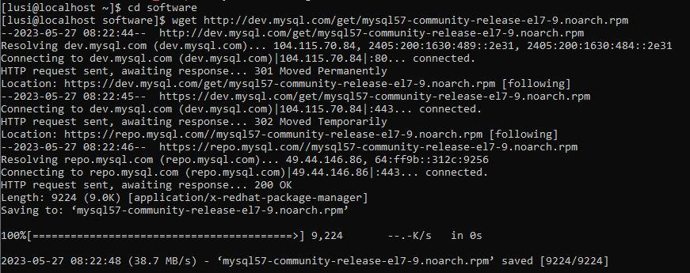

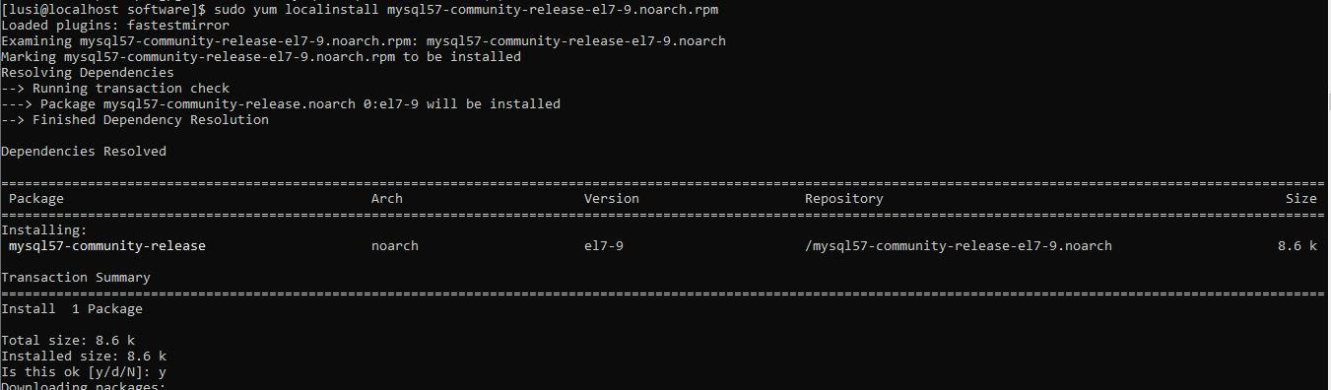



STEP3: Install the yum repository from the downloaded file



STEP4: install MySQL

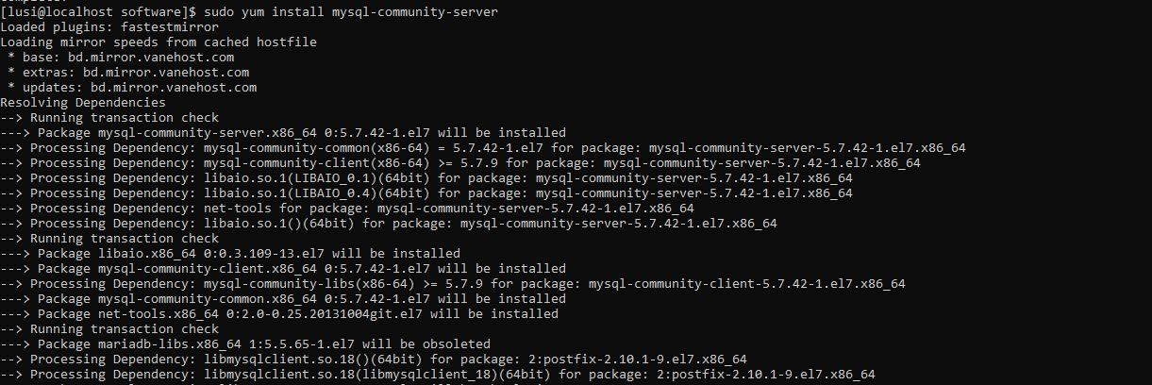

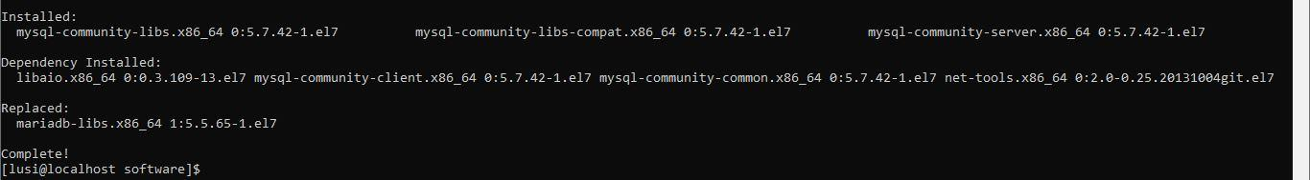

STEP5: a)Start the MySQL Server

b)generate temproray password

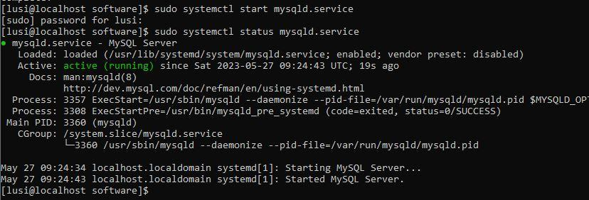

STEP6: login with the password

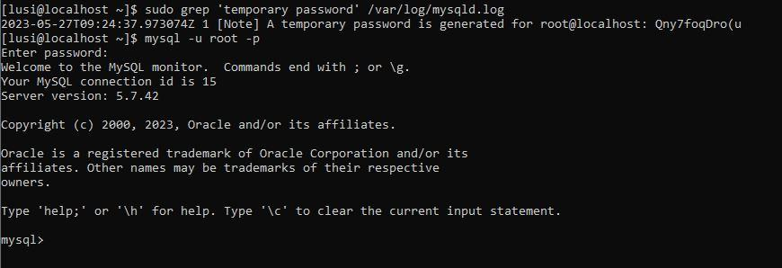

STEP7: Change root password



STEP8: create mattermost user



STEP9: Create the mattermost database



STEP10: Grant access privileges to the user “mmuser”

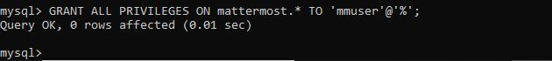

STEP11: a)Logout of mysql

b)set Mysql to start automatically





INSTALL MATTERMOST SERVER

STEP1: go to directory “software” and download the latest version of mattermost server

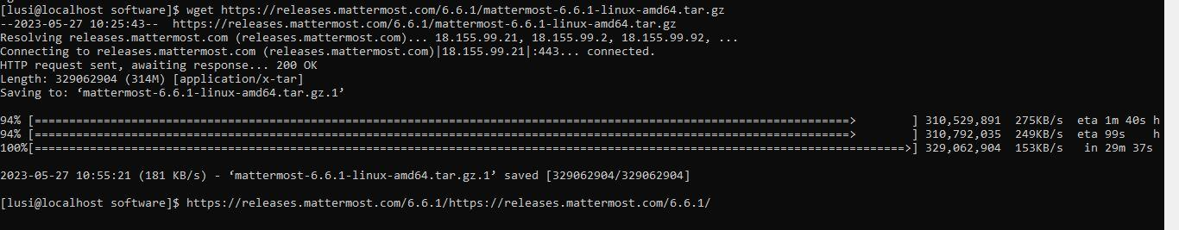

STEP2: Extract the mattermost server files

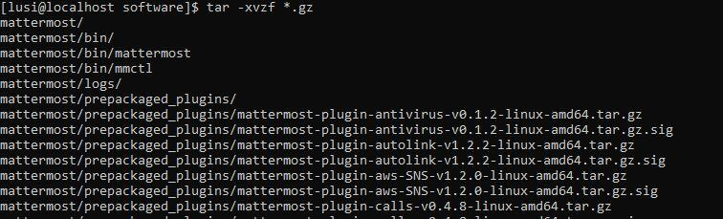

STEP3:a) Move the extracted file to /opt directory

b)create storage directory for files(/opt/mattermost/data)

c) create a system user and group called mattermost

d) set ownership permissions for mattermost and its child directories

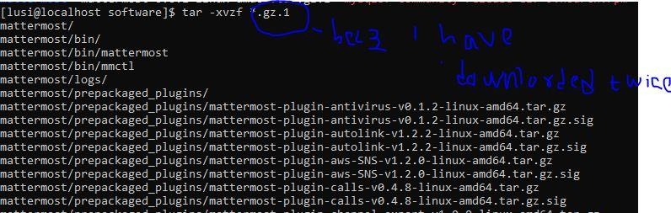





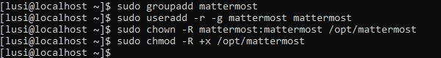

STEP4: open the database driver in the file

a)set drivername to mysql

b)set data source

c)set site URL

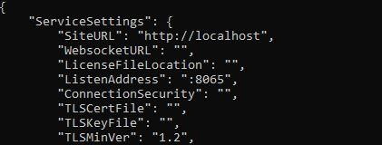

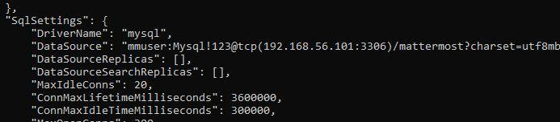

STEP5: a) Change to mattermost directory

b) start mattermost



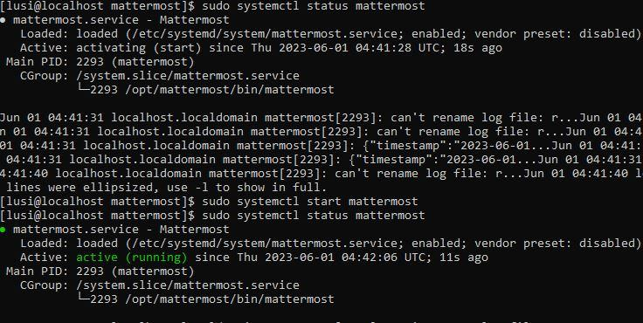

STEP6: Restart the mattermost and status mattermost

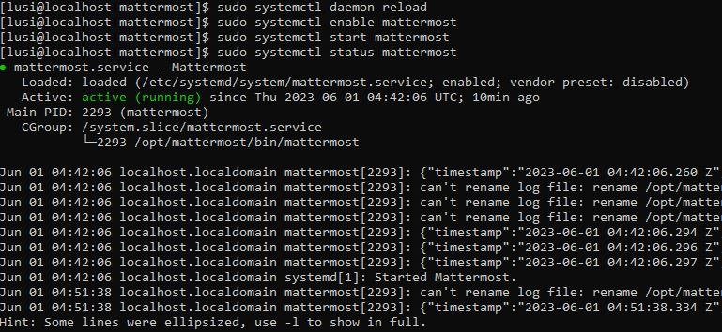

STEP7:

1 create mattermost configuration file

2.copy paste the command save and exit

3 .Set the configuration permission

4. Reload the system services

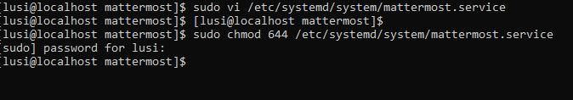

STEP 11: Set mattermost service to start on boot

STEP 12: Start the mattermost server





STEP 13: verify that mattermost is running

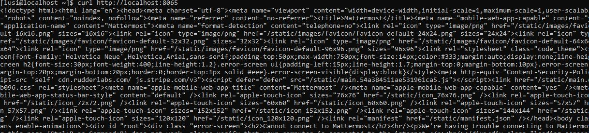

CONFIGURE MATTERMOST SERVER

Create the System Adminuser and setup Mattermost for general use. This can bed one from host windows machine

STEP1: Open a browser and navigate to your Mattermost instance.For example <http://192.168.56.101:8065>

STEP2: Create the first team and user. The first user in the system has the system admin role ,which gives you access to the System Console.

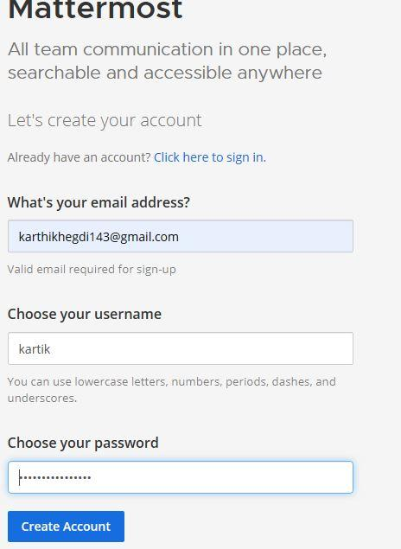



STEP 3: To open the System Console, select the Product menu in the top-left corner of the navigation panel, then select System Console



STEP4: Open System Console>Environment>WebServer

STEP5: In the Site URL field, set the URL that users point their browsers at.Forexample,http://localhost

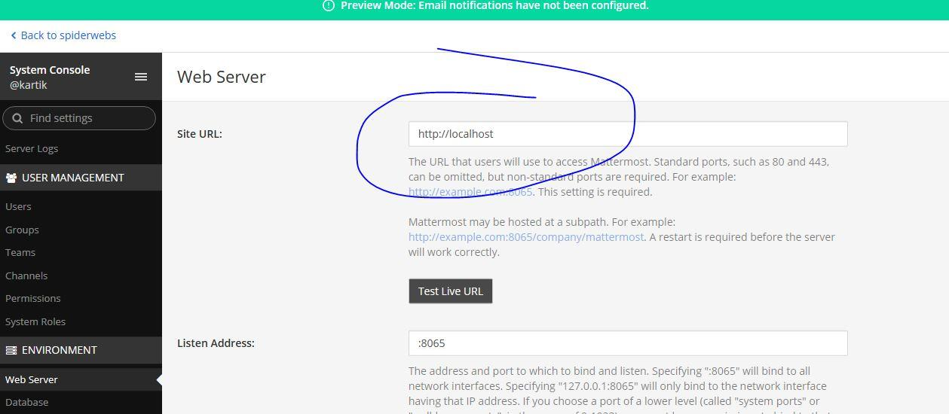

INSTALLING NGINX SERVER

STEP1: Create the file /etc/yum.repos.d/ngnix.repo



STEP2: Add the contents in the text editor

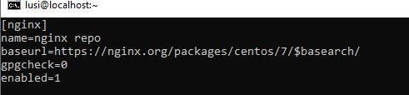

STEP3: install NGINX

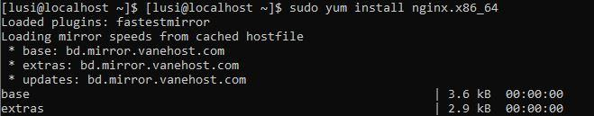

STEP4: START NGINX

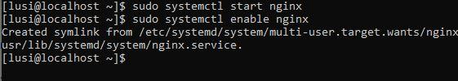

STEP5: Set NGINX to start at system boot

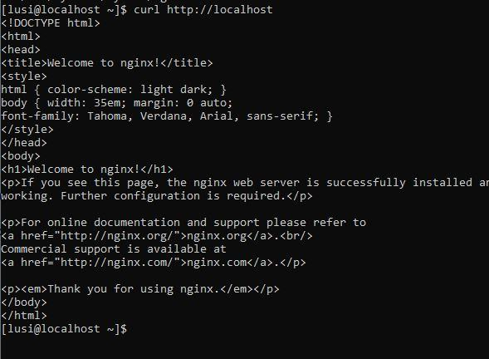

STEP 6: Verify that NGINX is running

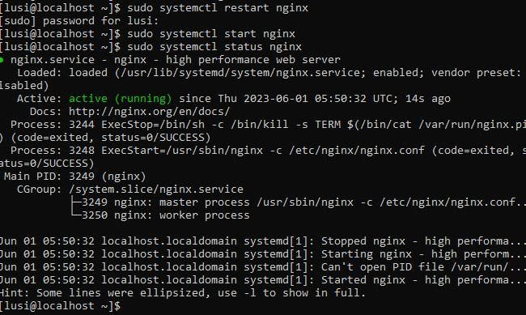

CONFIGURE NGINX AS A PROXY FOR MATTERMOST SERVER

STEP1: open file



STEP2:By providing the ip address type the command in text editor

Find the ip address and config accordingly

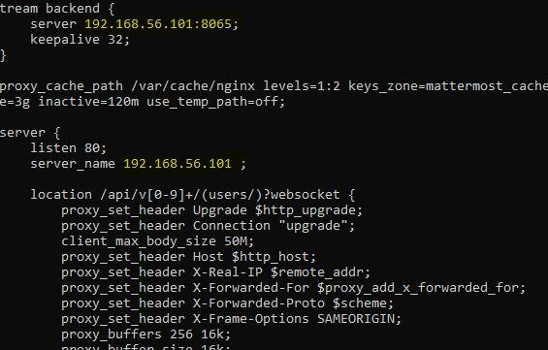



STEP3:Remove the existing default config file



STEP4: change owner for file /etc/nginx to nginx and change owner of the file /var/cache/nginx to nginx



STEP5: Enable the mattermost Configuration



STEP6: restart NGINX



STEP7: verify to see mattermost through proxy

